**N.B: Answer any two (02) out of three (03) Questions.**

1. Apply appropriate transformation to transform the following input image into the corresponding output images.

|  |  |  |
| --- | --- | --- |
| Input Image | Output Image | Output Image |

1. Apply geometric transformation to registered the following input image using the given reference image.

|  |  |  |
| --- | --- | --- |
| Reference Image | Input Image | Output Image |

1. 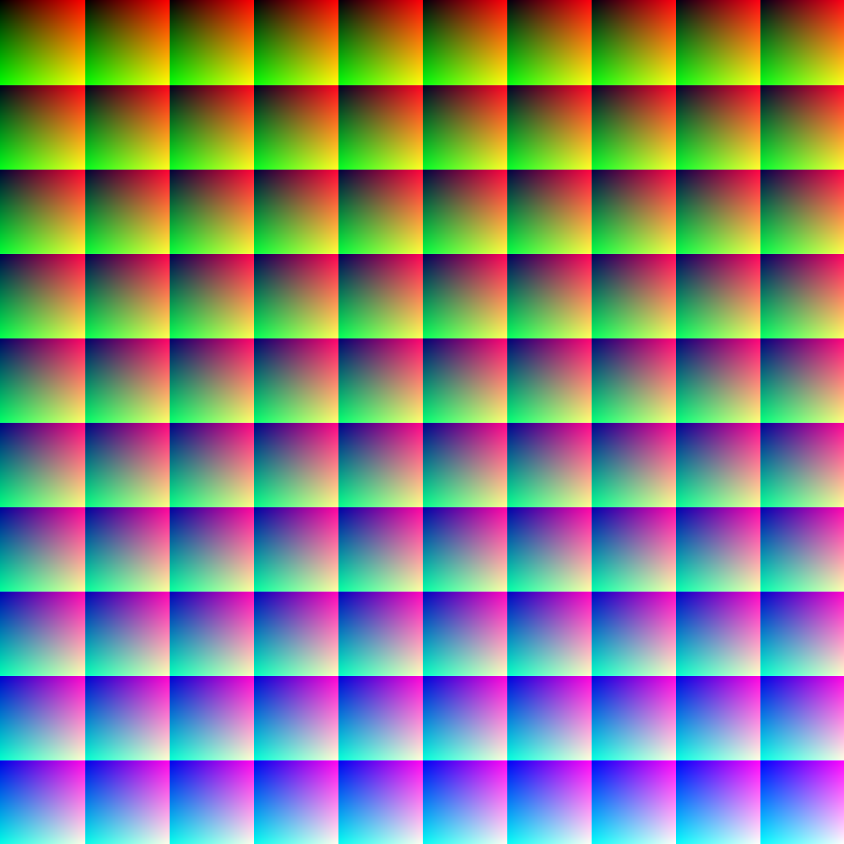Write a program to perform the following operations on the given input image:
2. Display the individual channels (R, G, B) pixel values in that image.
3. Separate the given color image in three R G & B color channels.
4. Separate the odd and even pixels of the following image into separate intensity arrays.
5. Convert the given color image into gray-scale image.
6. Draw the histogram of the following image.